**Probability of Default Modelling for Peer-to-Peer Lending**

**Dataset**

[All Lending Club loan data (kaggle.com)](https://www.kaggle.com/datasets/wordsforthewise/lending-club)

Over 1.3 Million Rows

Default Rate: 0.19

Base Case Model Accuracy: 0.81

**Feature Importance**

Predictive Power Scores of Features

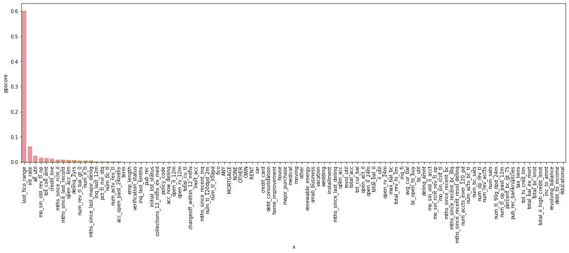

Machine Learning Model’s Feature Importances

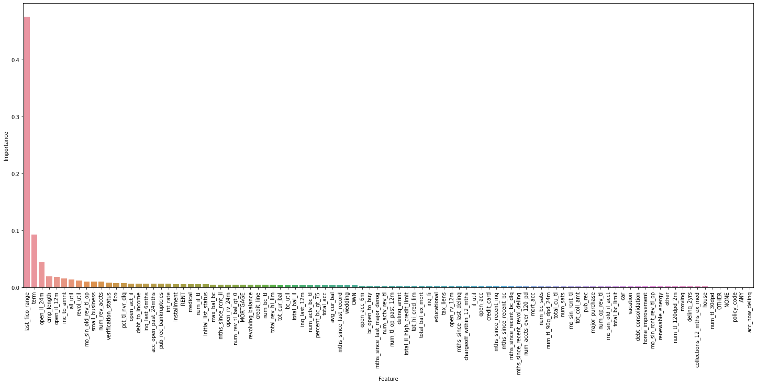

**Machine Learning Model Evaluation**

Training Data Performance

Accuracy: 0.88

AUC: 0.89

Validation Data Performance

Accuracy: 0.87

AUC: 0.89

Confusion Matrix

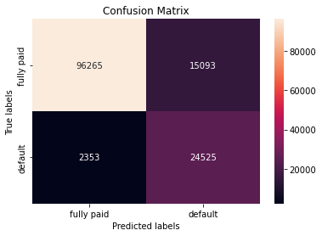

Model's Portfolio's Default Rate: 0.02

Accuracy when model predicts loan won't default: 0.98

Precision, Recall, F1-Score

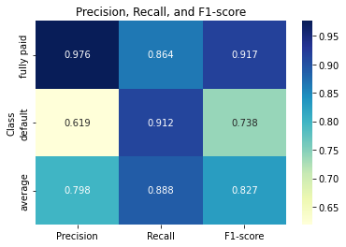

ROC Curve

